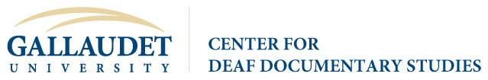
Capturing Deaf Heritage Day
Friday, October 28, 2016- Jordan Student Academic Center, MPR

9:00 – 3:30 – Photo Scanning Stations Open
Presentations: Student Hosts: Joey Aguilera, Natalee (Nayo) Franck

10:00 Digital Capture: Cultural Heritage Preservation
Greetings from CDDS Director: Brian Greenwald, PhD.
Archives Welcome and Preservation 101: Michael Olson
10:30 Stories from the Vault: Individual Collections are Important
William Ennis, PhD
Roberta J. Cordano, J.D.
Maggie Kopp
Kati Morton Mitchell
11:30 Film: Capturing, Storing and Restoring
Janie Golightly
Storm Smith
12:00 Objects: Collecting, Preserving, Interpreting and Display
Meredith Peruzzi
Drew Robarge
1:00 Writing Deaf Stories: Personal Memoirs and Manuscript Discovery
Kristen Harmon, PhD
Darlene Prickett, MFA
Octavian Robinson, PhD., College of the Holy Cross
Madan Vasishta, PhD
2:00 Lights, Camera, Access! Are there better ways to film sign?
Melissa Malzkuhn
Zilvinas Paludnevicius
3:00 Sustaining ASL Collections: What’s annotation and why does it matter?
Julie A. Hochgesang, PhD

Capturing Deaf Heritage Day is a collaboration of the Center for Deaf Documentary Studies and Gallaudet University Archives with assistance from the Office of Gallaudet Alumni Relations. This day is made possible by the generous support of the National Endowment for the Humanities.

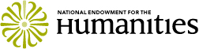

Created in 1965 as an independent federal agency, the National Endowment for the Humanities supports research and learning in history, literature, philosophy, and other areas of the humanities by funding selected, peer-reviewed proposals from around the nation. Additional information about the National Endowment for the Humanities and its grant programs is available at: www.neh.gov. Any views, findings, conclusions or recommendations expressed in this event do not necessarily represent those of the National Endowment for the Humanities.

