Pulse Secure VPN for Gallaudet University Managed Devices
These instructions are for installation of the Juniper Pulse Secure application on Gallaudet University managed devices only.

IMPORTANT NOTE: If you are using a Windows computer that has been turned off or taken off campus for an extended period of time, you will need to bring your computer on campus and connect it to the Gallaudet network. This must be done in order to catch up on all Windows security patches and software updates PRIOR to installing the new VPN application.

Instructions

If your computer is up-to-date and already has a VPN client/application installed (Juniper Pulse, Network Connect, etc.) then follow the steps below to install the new application. If you do not have a VPN client already installed, then you will need to bring your computer to campus to connect to Kace (software library) and request the installation (steps 3-12).

- Open up your existing VPN client and connect to the Gallaudet network (if you are not sure if you have an existing client, please contact the Help Desk)
- Once connected successfully, open any web browser (Chrome, Firefox, Safari, etc.)
- Go to https://k1000.gallaudet.edu and log in using your Gallaudet credentials

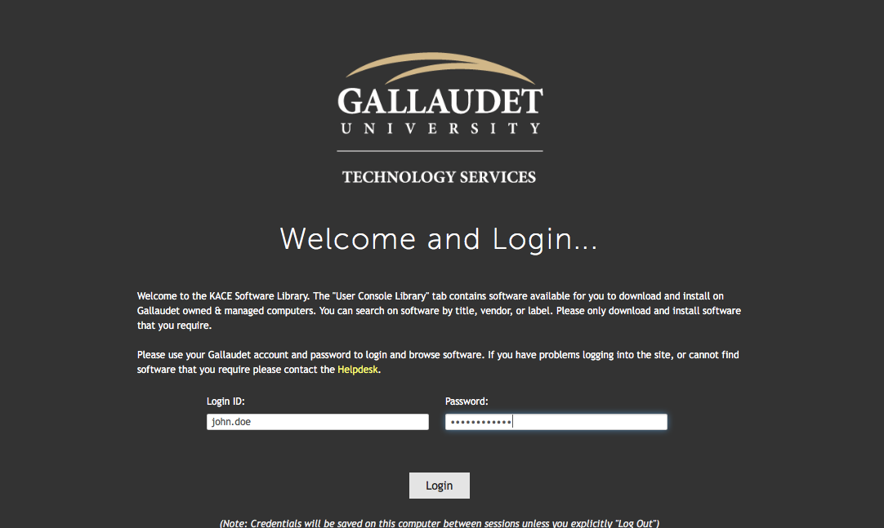
- Click on “Want software?”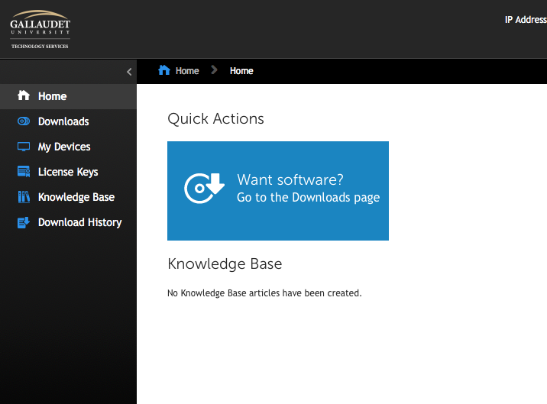
- Using the search box in the top right corner of the page, type in “pulse” then hit enter
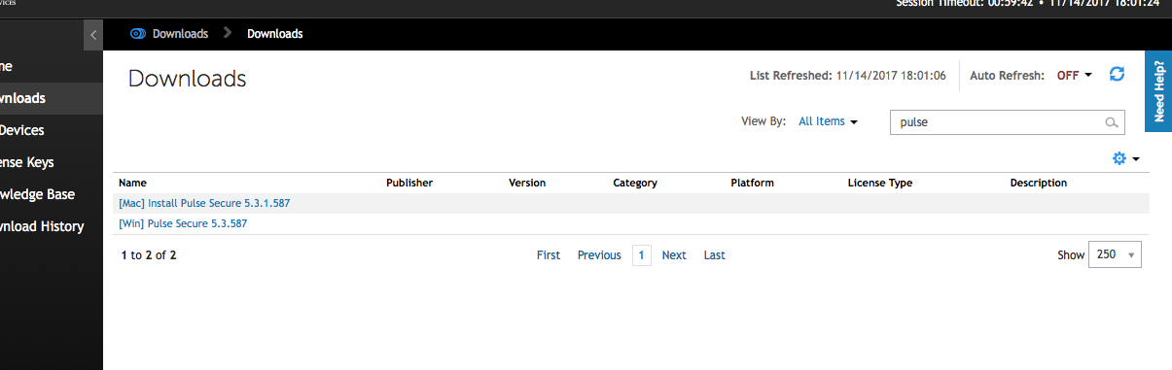
- Depending on your device type, select the Windows installation file [Win] or the Mac installation file [Mac] for Pulse Secure.
- Make sure the correct computer is selected for installation by verifying the computer name or the IP address (see circled fields in image below).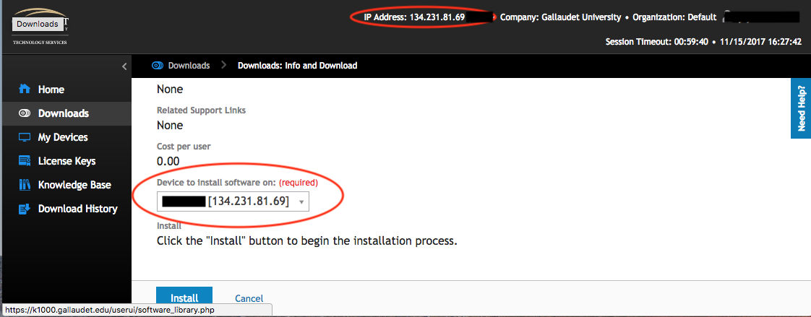
  - If the information matches, click on “Install” to proceed.
  - If either item does not match, then reboot your computer and follow steps 1-7 again. If it still doesn’t match, then contact the Help Desk for further assistance with connecting to Kace and installing the VPN client.
- Once you click on install, you will see a series of messages pop up over the course of a few minutes. You will be notified when Kace is checking to see if the application is running, the installation begins, or the installation is completed. Click on OK for each message to allow the installation process to continue to completion.
  - If you are prompted to save your connection information, select “Yes.” This will keep the connection information intact so that it appears in the new client automatically. If you say “No” then you will have to re-create the connection manually.
- You will know the application has been installed successfully when you see the “S” icon appear in the system tray or dock.
- To connect, click on the icon and a menu will appear with the option to connect. Select your Gallaudet connection.
  - If your connection information does not appear, click on the “+” sign to add it in. Give your connection a name (Gallaudet, GU computer, etc.) and type in https://remote.gallaudet.edu for the server URL. Once you click “add” you will be prompted for your Gallaudet credentials.
- To confirm that you are connected, the “S” icon should now have a green arrow.
- To disconnect from VPN, click on the icon again and the same menu will appear with the option to disconnect instead.

Please contact the Help Desk If you have any questions, comments, or if you encounter any issues with the instructions.

