2019 GALLAUDET UNIVERSITY
TRAINING MATCHES
MATCH 3, FINAL ROUND
CATEGORY: POPULAR CULTURE, LEISURE, AND SPORTS

Instructions: All answers will start with the letter “R”. Some answers may need to be capitalized.

- The NBA team for Houston goes by this name. | 1. ___________________________
- Name the actor who has performed in movies such as Deadpool and Green Lantern.  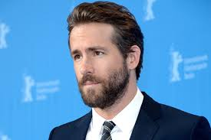 | 2. ___________________________
- Give the first name of the character in Archie Comics who is always chasing after Veronica and Midge, yet continuously loses them to Archie and Moose. | 3. ___________________________
- In which Disney movie does a mouse work in a restaurant in France? | 4. ___________________________
- This prolific illustrator created more than 300 covers for the Saturday Evening Post magazine. | 5. ___________________________
- Identify this fictional icon.  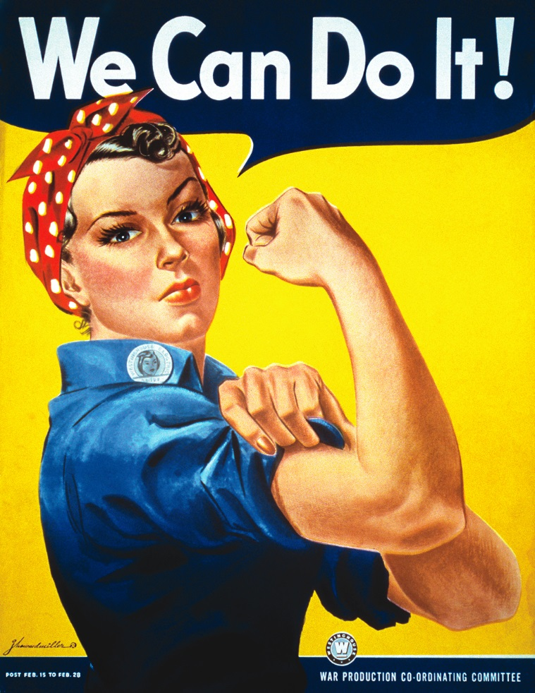 | 6. ___________________________
- Give the first name of David Beckham’s second son, also the name of a Shakespearean role Leonardo DiCaprio once played. | 7. ___________________________
- Brian Dunkleman and this man hosted American Idol from 2002 to 2016. Give his full name. | 8. ___________________________
- Give the name of Batman’s sidekick. | 9. ___________________________
- Name the television show that centers around Jimmy Chance who becomes a single parent to an infant after the mother ends up on death row. | 10. __________________________

