2019 GALLAUDET UNIVERSITY
PRACTICE MATCH 6, FINAL ROUND
CATEGORY: SOCIAL STUDIES

Instructions: Identify the following Hollywood stars.

 | 1. ___________________________
 | 2. ___________________________
 | 3. ___________________________
 | 4. ___________________________
 | 5. ___________________________
- 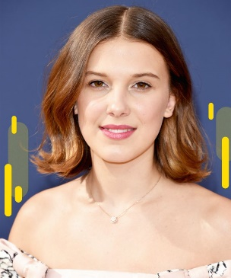 | 6. ___________________________
 | 7. ___________________________
 | 8. ___________________________
 | 9. ___________________________
10. | 10. __________________________

